# Fixing App Store “Could Not Complete Purchase: Unknown Error”

Often do we face the issue of some error that the particular request couldn’t be fulfilled.

Which inevitably leads to more frustration for novice users & professional users as the error codes are not easy to understand to begin with.

Lets face it , there are so many parameters for the software to be working perfect every time. With constantly changing internals with OS security updates , dependencies from other applications often the released software has some bugs which are not recognized until they are publicly release to work with different hardware configurations.

Thankfully debugging in todays internet full of resources is still nice , if you know a trusted tech source which provides all the documentation or support help to fix those bugs.

Even the Apple Support forms would be handy to find the solution , but it is very cumbersome to post questions & then follow up with the solution every time the expert says to do.

Fortunately if your problem has been experienced by lots of people there are more chances of the solution to be visible in first 10 search ranks on Google.

So we start of with the error first. Often do we get the error of “App Store” , when we try to Buy or Get an Application on App Store. It is mostly occasional but if you are facing this issue every other time you are trying to buy any application we suggest you to follow this steps.

Error Dialog Box Example.

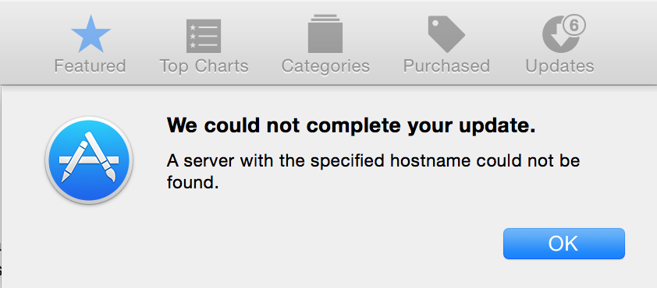

**Method 1 :**

Try to Quit all other applications , Force Quit “App Store” & Restart your Mac. Try your problem again , if still the problem persists. Move on to Method 2.

Also try to log out of the Apple ID from App Store & again sign in to see if the problem resolves.

**Method 2:**

1. Navigate to this folder

Open Finder, select Go > Go to Folder, option or Alternatively you can press “Shift + Command + G” for opening the small dialog box.

Further type “*~/Library/Preferences*” as included in the screenshot.



1. Search for “com.apple.appstore.plist” & "com.apple.storeagent.plist"



You may not get both of the “**.plist**” in that folder only 1 may be present that is perfectly fine.

1. Now Delete those files but before deleting we recommend you to take a backup in case if anything goes wrong. For system restore you should always be prepared. After that the App Store shouldn’t return any errors for “Get App” or “Buy App”.

Before Result :



Final Result 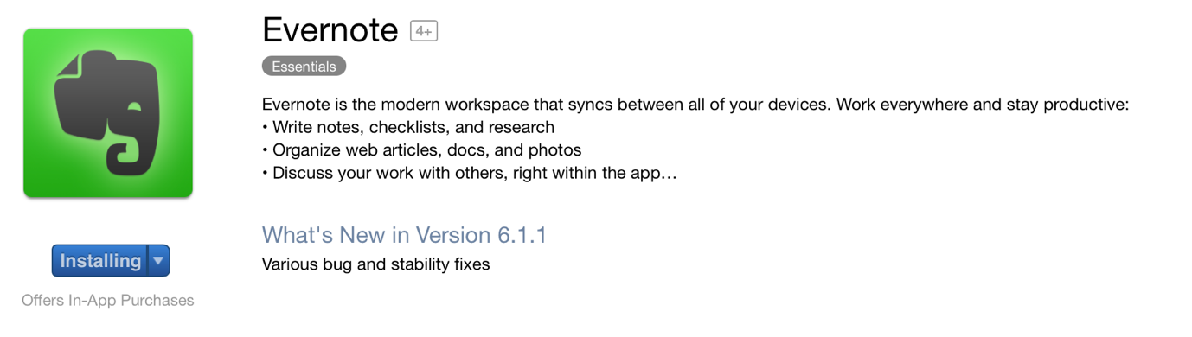

Let us know if you have any other solution in regards of this error which would be easier to follow.

We recommend **Method 2** but sometimes Method 1 works too. The article helps you get the problem resolved . We don’t take any liability for your data loss , So before proceeding with any steps always create System Restore Point.

Updates of the OSX mostly fixes errors in the next releases. We encountered this error in Mac OS X Yosemite on MacBook Pro 13” 2015.